Review of Related Literature

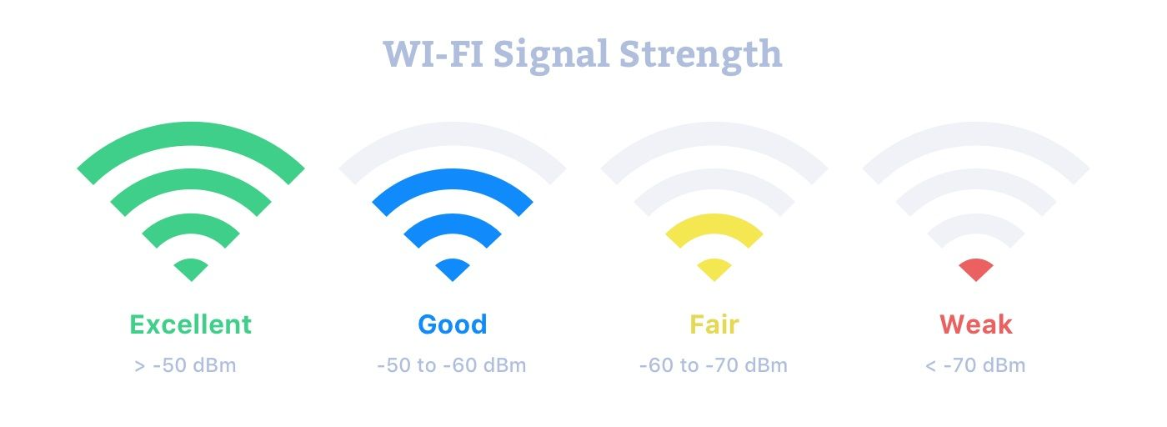

# Reasons for a weak Wi-Fi Signal:

Wi-Fi lets you build a network without the hassle of running cable, but these networks are highly dependent on signal strength. A weak Wi-Fi signal can reduce your available bandwidth and even cause connection problems. Tracking down and correcting issues that might be attenuating your wireless signal improve your network’s speed and reliability.

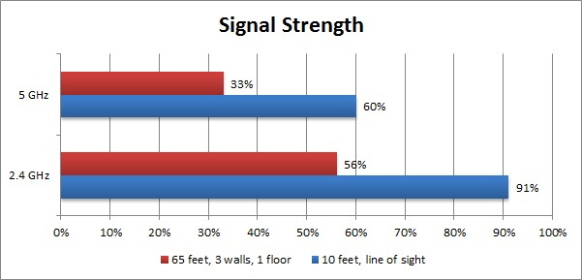  
  
Distance:

One of the most common causes of a low Wi-Fi signal is distance. Wireless routers and access points are limited to low-power broadcasts to prevent interference with other equipment, limiting their effective range to around 100 feet indoors. Newer 802.11n Wi-Fi products may increase that range somewhat, but if you need a reliable network over a large area, your best bet is to use additional wireless routers or repeaters to increase your coverage. The closer you are to a receiver, the stronger your signal will be.

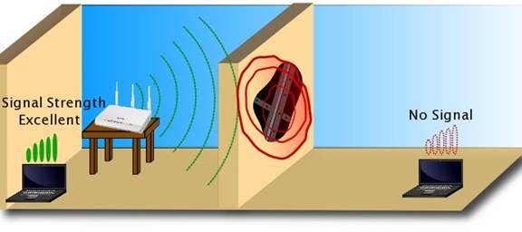  
  
Construction

If your Wi-Fi signal mysteriously drops off in certain rooms, it may be due to your home’s construction. Especially thick walls can muffle Wi-Fi signals, as can certain types of construction materials. In some older homes that contain plaster and lath walls, a metallic mesh inside the wall effectively disrupts any Wi-Fi signal passing through, significantly reducing signal strength or blocking the signal completely. Moving your routers and repeaters inside your home may help you find any troublesome construction, and let you place your equipment in configurations to avoid signal interference.

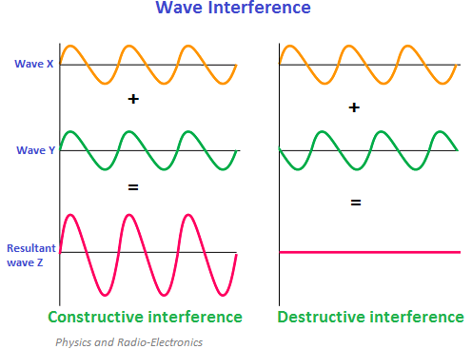

Other Wi-Fi Networks

Another source of Wi-Fi signal problems is interference. Wireless devices feature the ability to transmit and receive on several separate channels, but in many cases, they shift from the factory set to a single default channel. This can mean that several wireless sources in a small area, such as an apartment building, are all competing for signal in the same frequency band. If you encounter unexpectedly weak Wi-Fi signals and detect other networks operating in your immediate area, try switching to different channels to find a less crowded part of the spectrum.

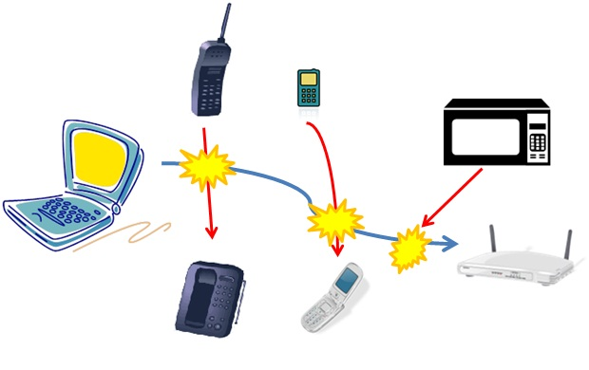

# Device Interference

You may also find intermittent signal problems caused by interference from other, non-Wi-Fi devices. Wi-Fi operates in the 2.4-gigahertz band, as do cordless phones and some remote alarm products. When active, these devices can reduce your Wi-Fi signal strength due to interference. Additionally, microwaves can produce substantial interference in the frequency range used by wireless devices and can completely disrupt a Wi-Fi connection. Taking care to situate your wireless nodes and equipment away from such interference can help improve signal strength, but repeated problems may require you to replace older appliances with modern, wireless-friendly alternatives or switch to the 5-gigahertz frequency band available with 802.11n products.

Methods of the Study

* Online Research
* Mechanical Approach
* Physics Laws
* Experimental Approach